FOR IMMEDIATE RELEASE CONTACT: Kim Ina
swc@swcfoundation.org
(415) 566-3487

SPORTS FOR THE WORLD’S CHILDREN TO HOST 10TH ANNUAL
“THEY ARE WORTHY” BENEFIT SOFTBALL TOURNAMENT

SAN FRANCISCO, May 8, 2007 – The Sports for the World’s Children Foundation (SWC) will host its 10th annual “They Are Worthy” benefit softball tournament the weekend of July 14 and 15 at Moscone Playground in San Francisco. Format will be round robin and/or double elimination for the coed comp and rec divisions, and men’s DD/C divisions. Participants are asked to bring any used and new sports equipment to support their cause: All donated equipment and proceeds from the tournament go to providing kids (and communities and schools) with much needed sports equipment, facilities, skills clinics, and mentoring programs. Equipment needed includes baseballs, bases, basketballs, bats, batting gloves, catchers' gear, Frisbees, hats, mitts, soccer balls, softballs, sports trading cards, sports uniforms (at least five alike), volleyballs, volleyball nets, etc. Entry forms can be found at www.swcfounation.org.

Last year a total of 15 teams participated in the three divisions of the tournament, and participants donated several hundred pounds of sports equipment.

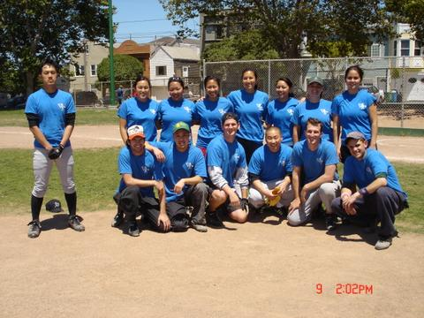

Champs of the Coed Rec. Division, FPOL.

This equipment was later transported to communities in Mexico, and delivered to more than 2,800 children in 22 schools, leagues, and sports clubs in dire need of sports equipment through SWC’s “Communities Play” sports equipment distribution and volunteer program in October and November of 2006. Fourteen volunteers from California, Washington, Ohio, and Michigan traveled to Mexico with SWC to help with the sports equipment distribution effort and provide skills instruction and training, and Alaska Airlines donated extra cargo space needed to transport the equipment.

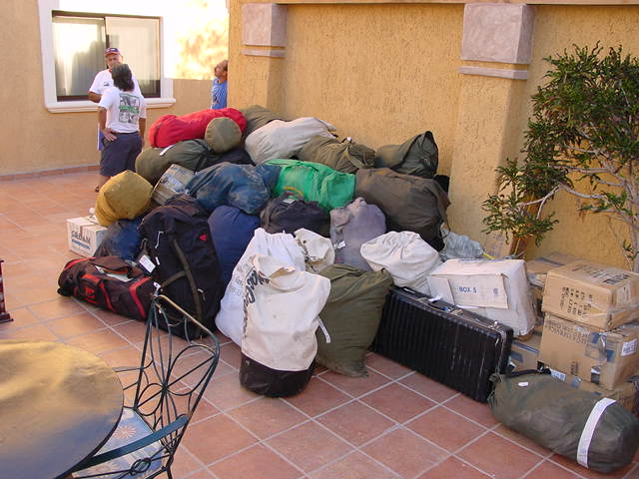

Sports equipment arrival in Loreto, Baja California Sur, Mexico, October 31, 2006.

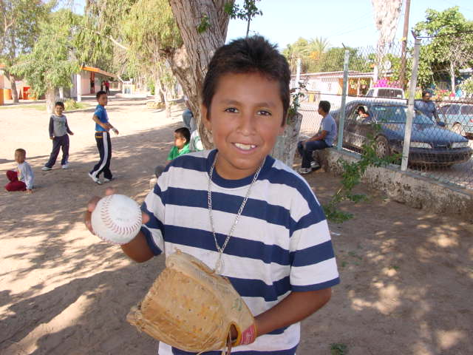

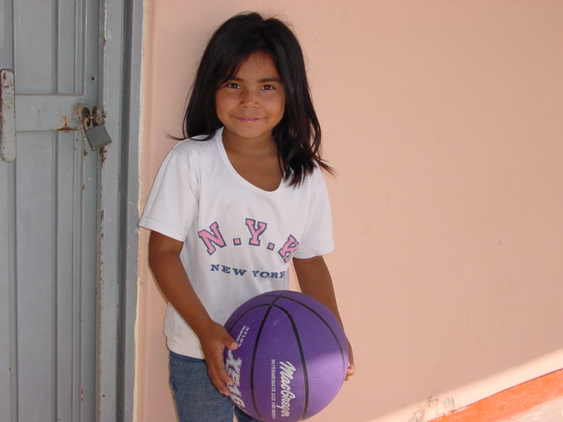

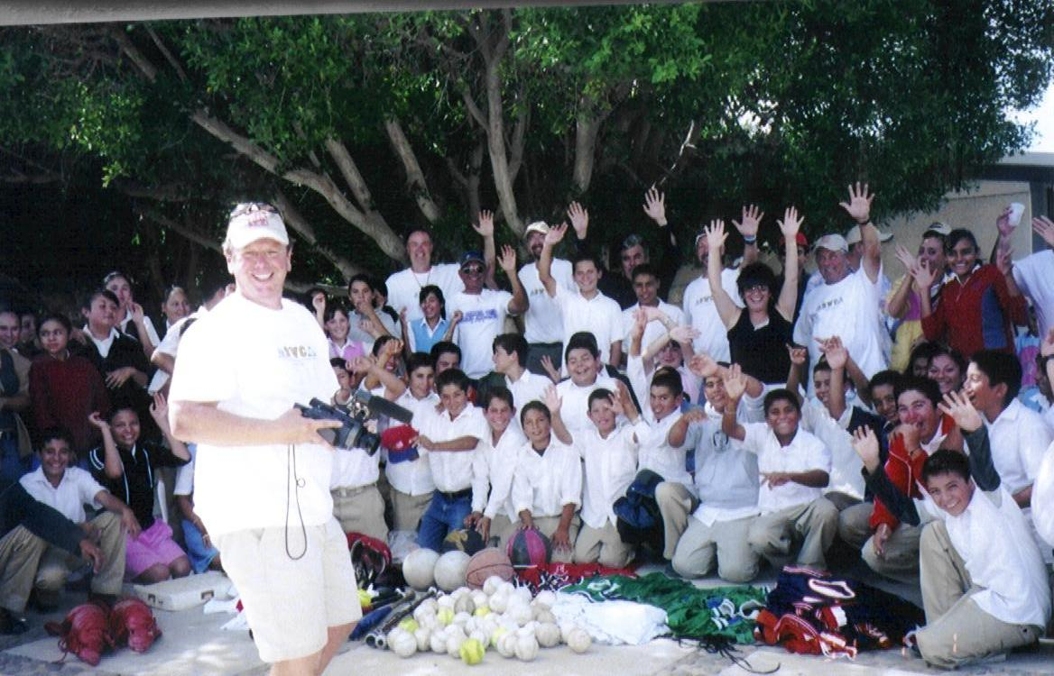

Equipment donations in Ignacio Zaragoza, a community outside of Insurgentes,
Baja California Sur, Mexico, Nov. 3, 2006.

The Sports for the World’s Children Foundation (SWC), based in San Francisco, has been a long time supporter of youth participation in sports in California and Mexico. SWC’s mission is to facilitate the creation of ongoing, self-sustaining, quality sports programs for children with limited or no resources. Over the past nine years, SWC has benefited more than 13,400 children, ages 5-18, by providing them with thousands of pounds of sports equipment and sports skills instruction and training through its “Communities Play” Program. SWC’s “Communities Play” Program has received past support from Alaska Airlines, Major League Baseball’s Baseball Tomorrow Fund, and the Kristi Yamaguchi Always Dream Foundation.

Interested individuals, teams, and/or sponsors can contact SWC for more information about the benefit softball tournament, their “Communities Play” sports equipment distribution/volunteer program to Mexico, and/or to order a DVD about their programs at swc@swcfoundation.org, (415) 566-3487.

# # #

